|  |  |
| --- | --- |
|  | **<Organic Kundapura>**  **Technical Design Document** |
| |  |  |  |  | | --- | --- | --- | --- | |  | **Prepared By / Last Updated By** | **Reviewed By** | **Approved By** | | **Name** | Varun M < 2321982 > |  |  | | **Role** | Programmer Analyst Trainee |  |  | | **Signature** |  |  |  | | **Date** | 16-02-2024 |  |  | |
|  |

Table of Contents

1.0 Introduction 3

1.1 Purpose of this document 3

1.2 Project overview 3

2.0 Solution Summary 3

2.1 Scope 3

2.2 Assumptions 3

2.3 Dependencies 3

2.4 Risks 3

3.0 Schematic Diagram 3

4.0 System Design 4

4.1 Proposed design 4

4.2 Component inventory 4

5.0 Database Design 4

5.1 Data Model 4

5.2 Tables Structure 4

6.0 Appendices 4

6.1 Glossary 4

6.2 Other 5

7.0 Terms & Conditions 5

8.0 Change Log 5

# Introduction

## Purpose of this document

The organic food market is booming, with consumers increasingly seeking healthier, locally sourced products. Develop a user-friendly platform, “Organic Kundapura Store”, where users can browse, purchase, and review organic products directly from farmers in Kundapura.

Implement administrative features for managing product inventory, including adding, updating, and removing items. Incorporate a robust customer service system to ensure smooth interaction between administrators, farmers, and users. This initiative not only taps into the growing market for organic products but also supports local farmers, promoting sustainable agriculture and contributing to the local economy.

## Project overview

The "Organic Kundapura Store" is an innovative digital platform, that brings the farm to your doorstep. It's a unique initiative that connects consumers directly with local farmers from Kundapura and its surrounding villages. The store offers a wide range of organic products, all cultivated through natural farming methods.

The platform is more than just an e-commerce site; it's a community hub that promotes sustainable agriculture. It empowers local farmers by providing them with a direct sales channel, eliminating the need for intermediaries.

Moreover, the store is a testament to Kundapura's rich agricultural heritage, offering everything from chemical-free vegetables to wholesome dairy products. It's a movement that encourages sustainable living and supports the local economy. In a nutshell, the "Organic Kundapura Store" is a technological solution for a healthier and more sustainable future.

# Solution Summary

## Scope

The "Organic Kundapura Store" has immense potential for growth and expansion in the future. Here are some areas of future scope:

1. Direct Farmer-Consumer Transactions: The platform can be further developed to facilitate direct transactions between farmers and consumers, eliminating the need for any intermediaries. This will ensure that farmers receive fair compensation for their produce and consumers get the best prices.

2. Youth Engagement in Agriculture: The store can initiate programs to attract and engage youth in the field of farming and agriculture. This could include training workshops, internships, and mentorship programs that provide hands-on experience in organic farming practices.

3. Community Building: The store can host events and activities that foster a sense of community among consumers and farmers. This could include farm visits, farmer's markets, and community gardening projects.

In essence, the future of the "Organic Kundapura Store" lies in strengthening the bond between farmers and consumers, promoting sustainable practices, and fostering a community that values and supports local, organic produce. It's a vision of a future where technology and nature work hand in hand for the benefit of all.

## Assumptions

*<This sub-section shall state the assumptions of this detailed design document>*

## Dependencies

*<This sub-section shall state the dependencies for this project>*

## Risks

*<This sub-section shall state the risks predicted for this project>*

# Schematic Diagram

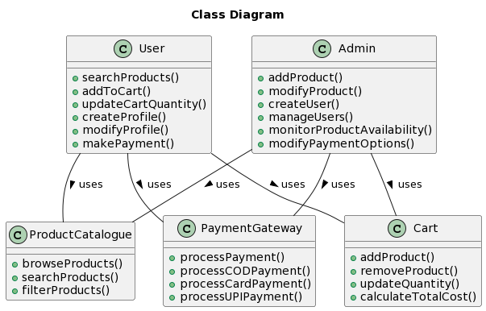

# System Design

## Proposed design

*<This sub-section shall elaborate the high-level design for this project>*

## Component inventory

*<This sub-section shall list the components for this project>*

# Database Design

## Data Model

*<This sub section will give the schematic view of the database design>*

## Tables Structure

*<This sub section will describe the table structure>*

|  |  |  |  |
| --- | --- | --- | --- |
| **Column Name** | **Data Type** | **Length** | **Nulls** |
|  |  |  |  |

# Appendices

## Glossary

|  |  |
| --- | --- |
| **Acronyms** | **Definitions** |
|  |  |

## Other

# Terms & Conditions

***Disclaimer: Please do not circulate or distribute this document outside of Cognizant Network, We have a Zero Tolerance Policy. Kindly adhere to 100% Compliance at all times.***

# Change Log

*Please note that this table needs to be maintained even if a Configuration Management tool is used.*

|  |  |  |  |  |
| --- | --- | --- | --- | --- |
| Version Number | Changes made | | | |
| V<n.n> | *<If the change details are not explicitly documented in the table below, reference should be provided here>* | | | |
| Page no | Changed by | Effective date | Changes effected |
|  |  |  |  |
|  |  |  |  |
|  |  |  |  |
|  |  |  |  |